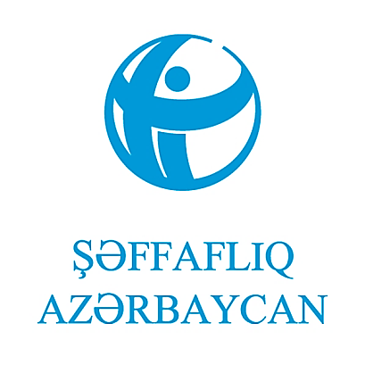
Azərbaycan, Bakı.
Balaba Məcidov küç.,51
E-mail: alimammad@transparency.az
Tel: (+99412) 5951547
Mobil: (+99450) 2232929
https://transparency.az/

"Transparency Azerbaijan" Fight Against Corruption PU

Annual Report

For 2023

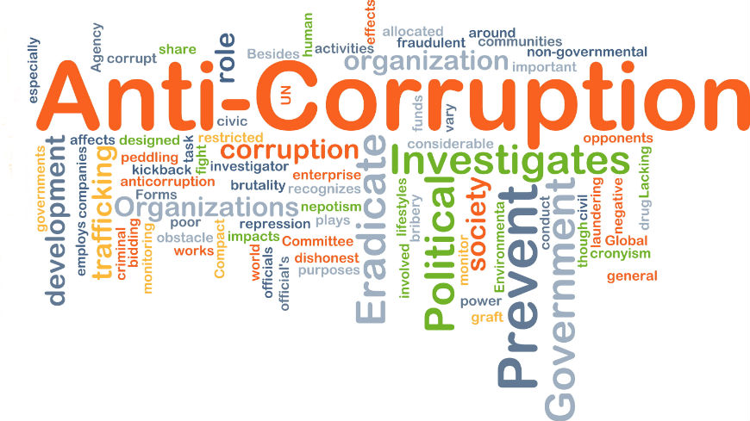

This report reflects the activities carried out by the "Transparency Azerbaijan" Anti-Corruption Public Union during 2023, the information and facts about the achieved achievements, the difficulties it faces, and ideas about future plans.
December 17, 2023 meeting of the Board of Directors of the "Transparency Azerbaijan" Anti-Corruption Public Union .

Azerbaijan Baku.
Balaba Majidov St., 51
E-mail: alimammad@transparency.az

Phone: (+99412) 5951547
Mobile: (+99450) 2232929
https://transparency.az/

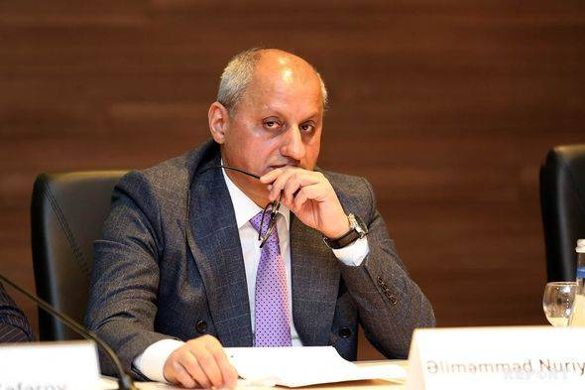
Preface
The year 2023 can be considered as a complicated period for "Transparency Azerbaijan" Anti-Corruption Public Union. It can be noted that the calls of previous years remain relevant this year also. In particular, it is necessary to mention that the legislation regulating the activities of NGOs remains unchanged, and the termination of Azerbaijan's activities in the OGP as the main difficulty. The legislation regulating the activities of NGOs has greatly limited the access to foreign donors and the collection of donations. This environment also affects the motivation of the private sector, and cooperation with civil society is mostly limited to charitable actions and initiatives to increase educational opportunities. Initiatives of NGOs related to public issues are not supported by the private sector. The conflict of interest policy does not allow "Transparency Azerbaijan" to receive funding from government donors. Many foreign donors do not consider the participation of NGOs from Azerbaijan in grant competitions. Because, later, there is a high possibility of a problem with the registration of grant contracts or service contracts.
"Transparency Azerbaijan" tries to respond to these challenges by holding discussions with the government, providing consultation and supporting other initiatives and public discourse related to these issues. Unfortunately, no progress in this direction can be noted in 2023.
As the positive aspects of 2023 it can be mentioned, the adoption of the Competition Code and the new law "On Public Procurement" promoted by "Transparency Azerbaijan" for a long time. Let me present the proposals of "Transparency Azerbaijan" regarding both draft laws. The proposals were carefully considered and largely adopted.
It is possible to mention the detailed report announced by the Anti-Corruption Commission on the one-year implementation of the " 2022─2026 National Action Plan on strengthening the fight against corruption ". "Transparency Azerbaijan" presented its proposals regarding the effective implementation of the Plan and ensuring accountability. Some of the proposals have been partially accepted.
The lack of improvement in Corruption Perception Index (CPI) of our country compared to other countries of the region in recent years, as well as to the previous period is a serious concern of "Transparency Azerbaijan". In this regard, "Transparency Azerbaijan" expressed its concerns and opinions about the work to be done directly to the government officials. This position was also expressed in public statements.
Sincerely,
Alimammad Nuriyev
Executive Director

Board meetings
In 2023, the Board of Directors of "Transparency Azerbaijan" Anti-Corruption Public Union held 6 meetings. 11 issues were discussed at the meetings.
The Board of Directors tried to ensure the implementation of the activities envisaged in the Annual Action Plan under the conditions of limited resources.
On the initiative of the Chairman of the Board of Directors, proposals on NGO legislation were prepared and presented, unless it is provided for in the Annual Action Plan.
At the meetings of the Board of Directors, discussion and adoption of the Competition Code, draft law "On Public Procurement", monitoring report of one-year implementation of the " 2022─2026 National Action Plan on Strengthening the Fight Against Corruption", position of Azrbaijan in the Corruption Perception Index (CPI), accreditation of the national chapter by the Transparency International, initiatives to create a favorable environment for NGOs were discussed and decisions were adopted.
Proposals of "Transparency Azerbaijan".
"Transparency Azerbaijan" prepared proposals related to the draft of Competition Code, which was submitted to the government for approval in 2022 by the State Service for Antimonopoly and Consumer Market under the Ministry of Economy and which was submitted to the Milli Majlis (parliament) on February 2023. The proposals were submitted to the Ministry of Economy and the Anti-Corruption Commission in February. The proposals prepared so far by "Transparency Azerbaijan", as well as the proposals prepared by the Entrepreneurship and Market Economy Development Assistance Fund, as well as the proposals prepared by NGOs and independent experts, have been summarized and systematized. The generalized proposals actually reflected the position of the civil society .
"Transparency Azerbaijan" discussed the one-year results of the implementation of the "2022─2026 National Action Plan on Strengthening the Fight Against Corruption" approved on April 4, 2022 and presented proposals for effective implementation. According to the preliminary analysis of "Transparency Azerbaijan", measures on 8 points in the Action Plan implementation is planned to be completed in 2023. Preliminary analyzes show that two of the measures have been implemented partially, 1 measure has been fully implemented, and 5 measures have been implemented by 70%. Especially, bringing the number of courts connected to the "Electronic court" information system to 89, which is 77% of all courts, can be marked as progress. The most noteworthy issues are the delays in the implementation of measures that are supposed to be completed in 2022 and 2023. Executive director Alimammad Nuriyev noted that the main measures will start in 2023 and the implementation of many measures should be completed in 2024-2025. Therefore, it is necessary to keep in mind the implementation of the Action Plan.

"Transparency Azerbaijan" prepared and submitted proposals for the draft law "On State Procurement" which was submitted to the Milli Majlis at the beginning of 2023 . "Transparency Azerbaijan" constantly identifies the field of public procurement as one of the areas with a high risk of corruption. In order to effectively fight against corruption, provide transparency and accountability in this field, he consulted the state bodies, conducted monitoring and research and prepared recommendations and proposals. "Transparency Azerbaijan" in 2016-2018 conducted a study on transparency mechanisms in public procurement. Analysis of international experience by "Transparency Azerbaijan" on the initiative "Increasing transparency in public procurement" within the "Civil Society Support Program" funded by the Ministry of Foreign Affairs of the Kingdom of the Netherlands in 2020 and implemented by the Caucasus and Research and Resource Center-Georgia organization and A Research Report was prepared based on the monitoring of the Unified Electronic Portal of E- procurement in Azerbaijan's.

Research Report deficiencies and gaps in the field of ensuring transparency and accountability in public procurement in the Republic of Azerbaijan were analyzed, the provisions that create the risk of corruption, leading to corrupt deals and making subjective decisions were evaluated, and the effectiveness of transparency mechanisms was evaluated.

The report also reflects proposals for improving the system of transparency in public procurement. "Transparency Azerbaijan" experts have also defended the approach of adopting a new law that will regulate public procurement from 2020. During that period, the Report was submitted to the Ministry of Economy, discussions were held with the Ministry, and the proposals reflected in the Report were widely covered in the mass media. 3 large articles of the Executive Director were published on this topic. The proposals contained in the report are still relevant today, and their necessity becomes more apparent as time passes.

In 2017, the "Transparency Azerbaijan" participated as a partner in the "Transparent Public Procurement Rating" project implemented by the Georgian Institute for the Development of Freedom of Information. Within the framework of the project, the evaluation of the legislation in the field of public procurement was carried out in the "Eastern Partnership" member states - Azerbaijan, Belarus, Armenia, Georgia, Moldova and Ukraine, and civil society representatives of 5 countries were also involved in the evaluation as partners. Recommendations regarding the improvement of the legislation of Azerbaijan were included in this study .
The report and proposals were submitted to the Ministry of Economy, the Anti-Corruption Commission .

Legislation regulating the activities of NGOs initiatives related to improvement

With initiative of the Chairman of the Management Board, Hafiz Hasanov, On meeting of "Transparency Azerbaijan" held on June 27, 2023, It was decided to submit proposals on improovment of NGO legislation prepared and revised by "Transparency Azerbaijan" experts, which reflects "Transparency Azerbaijan" position to the Anti-Corruption Commission and the State Support Agency. These proposals were severally sent to state bodies on different times for.

These proposals were presented again by the Executive Director at the meeting of the "Corruption and Transparency" working group of the Commission on Business Environment and International Ratings held on 26.09.2023 .

The position of the National Chapter in relation to the Corruption Perceptions Index 2022 (CPI 2022)
the 2022 Corruption Perception Index (CPI 2022) was released by the National Chapter on January 31, 2023. A corresponding press release has been issued. Information called "Frequently Asked Questions" has been released. The media's questions have been answered .
In 2022, Azerbaijan received 23 points and ranked 157th. of CPI in total, 13 different reports were used in its preparation. These reports evaluate the position of countries on a number of political, economic and social criteria that affect the effectiveness of anti-corruption policy .
Azerbaijan's CPI score was prepared as a result of the analysis of data received from 7 different sources in the last 9 years, and 6 sources were used for 2022. This time World Economic Forum Executive Opinion Survey (EOS) – results was not used. The lack of World Economic Forum source led to the statistical decline of the results in the Azerbaijan CPI of the country. Thus, according to the other 4 reports, the indicators of Azerbaijan are unchanged, one report, according to the Varieties of Democracy Project report, Azerbaijan received one point more than last year.
The Executive Director of "Transparency Azerbaijan" shared concerns and suggestions with the Anti-Corruption Commission and the National Coordinator for Open Government Partnership .

Cooperation with state bodies
"Transparency Azerbaijan" conducted free anti-corruption training for the employees of the Shusha State Reserve and the employees of the Penitentiary Service of the Ministry of Justice. The Executive Director of "Transparency Azerbaijan" continued to work in the "Corruption and Transparency" working group of the Commission on Business Environment and International Ratings. He participated in three meetings of the group held in 2023. The proposals of "Transparency Azerbaijan" were presented in both sessions.
"Transparency Azerbaijan" Executive Director continued working in the "Legislation improvement" Working Group of the Anti-Corruption Commission. The executive director participated in a meeting of the group held this year and presented the proposals of the national chapter.
Provision of paid services
"Transparency Azerbaijan" signed a service contract only with the State Agency for Compulsory Medical Insurance in connection with the implementation of point 5.2 of the Action Plan on the "Strengthening the fight against corruption for the 2022─2026 years " or the implementation of anti-corruption trainings and the preparation of educational materials. 4 trainings were held for the agency. At the same time, a flyer was prepared, printed and delivered to the Agency.
Preparation of project proposals
Within the country, only UN structures and organizations such as the International Red Cross, which operate according to interstate agreements, announce grant competitions on topics relevant to vulnerable groups of the population. "Transparency Azerbaijan" applied to the OHCHR and the UNDP Azerbaijan national branch with a project proposal for 2023. However, the projects could did not win the competition.
Public Relations
During the reporting period, "Transparency Azerbaijan" issued 12 press releases and also posted 21 materials on its Facebook account. More than 20 statements and interviews of the executive director have been published.
Challenges faced by "Transparency Azerbaijan".
2023 was a complicated year for NGOs, like last year. Again, the previous calls remain relevant, the expected changes to NGO legislation have not occurred, and NGOs do not have the opportunity to receive grants from foreign donors.
According to ammendments made in the NGO legislation in 2014-2015, only foreign organization registered as a donor organization in Azerbaijan can give a grant to an NGO operating in Azerbaijan. Until now, following this difficult and complicated procedure, no organization has been registered as donor in Azerbaijan.
Azerbaijan remains the only country in the world that requires registration of service contracts signed by NGOs. Also, even a dollar donation must be registered with the Ministry of Justice. Therefore, crowdfunding is not possible. Cash donations over $70 cannot be made. Foreign citizens and legal entities cannot donate.
Due to this attitude, local business avoids cooperation with NGOs.
"Transparency Azerbaijan" is in complicated situation, due to the conflict of interest policy it cannot receive grants from national donors. Within the country, UN structures and organizations such as the International Red Cross, which operate according to intergovernmental agreements, announce grant competitions on topics relevant to vulnerable groups of the population in their grant announcements. The subject and priorities of these competitions are agreed with the government in advance. The removal of Azerbaijan from the OGP had a serious negative impact on the activity environment.
Only with the personal efforts of the Executive Director and the Board of Directors it is possible to keep minimum activity of the national chapter.
Plans and priorities for 2024
"Transparency Azerbaijan" will first of all try to implement the recommendations of the International Transparency for institutional development.
"Transparency Azerbaijan" intends to expand the scope of paid training and consulting services.
It is one of the priorities to provide state bodies with quality expertise and to continue providing consultation.
Monitoring the "2022─2026 National Action Plan on Strengthening the Fight against Corruption" are among the main tasks.
The analysis and discussions conducted by "Transparency Azerbaijan" and consultations with government officials suggest that the challenges and risks of the new year will remain relevant in 2024. It is very unlikely that there will be positive changes in NGO legislation.
"Transparency Azerbaijan" plans to establish partnership relations with the UN High Commissioner for Human Rights , the German Society for International Cooperation ( GIZ ), the Confederation of Azerbaijan Trade Unions, the State Agency for Compulsory Insurance and the Anti-Corruption Commission on 2024.
Anti-corruption training is planned for the Confederation of Trade Unions and for the State Agency for Compulsory Insurance .
Proposals will be submitted to the UN High Commissioner for Human Rights, the German Society for International Cooperation ( GIZ ), and the Anti-Corruption Commission .
The national unit will discuss cooperation with the UNDP and the British Embassy.

https://transparency.az/eng/qht_ganunvericiliyi_teklifler_transparency_azerbaijan/
https://transparency.az/eng/transparency-azerbaijan-prepared-proposals-to-the-new-draft-law-on-procurement/regabet-mecelllesi-teklifler/
https://transparency.az/eng/transparency-azerbaijan-discussed-the-implementation-of-the-national-action-plan-and-prepared-proposals/nap_recommendations/
https://transparency.az/alac/files/Satinalmalar_Policy_Paper.pdf
http://kafondu.org/wp-content/uploads/2020/08/Satinalamaram_Hesabat_T%C4%B0_Azerbaijan_New.pdf
https://transparency.az/eng/qht_ganunvericiliyi_teklifler_transparency_azerbaijan/
https://azranking.az/az/article/Biznes%20m%C3%BChiti%20v%C9%99%20beyn%C9%99lxalq%20reytingl%C9%99r%20%C3%BCzr%C9%99%20Commissioner% C4%B1n%20%E2%80%9CCorruption%20v%C9%99%20%C5%9F%C9%99ffafl%C4%B1q%E2%80%9D%20i%C5%9F%C3%A7i%20group% 20n%C3%B6vb%C9%99ti%20iclas%C4%B1%20ke%C3%A7irilmi%C5%9Fdir-1.html

